Chapter – 12: Some Natural Phenomena

* Over years – humans – developed many machines – invented new technologies
* All these technology – cannot compare to power of nature
* One storm, tsunami, earthquake – wipe out years of construction and machinery
* Power of nature – cannot be controlled – BUT – effects can be reduced – understand them better
* Events, incidents – due to natural forces – natural phenomena
* Destructive events – loss of life and property – natural calamities (disasters)

# Earthquake

* Slight vibration, violent shaking – earth’s surface
* Natural phenomena – very dangerous if intensity – very high
* Magnitude (intensity) – measured using Richter scale
* Magnitude – 3 or lower – hard to notice
* Magnitude – 4-6 – moderate – disturb loose structures and objects
* Magnitude – 7 or higher – very dangerous – damage permanent structures

# How are Earthquakes Caused?

* Earthquake – result of release of energy – stored in earth’s crust – creates seismic waves
* Seismic wave – wave of vibration – travel through earth
* Seismic waves – recorded by seismographs – intensity of waves
* Seismograph – simple instrument – consist suspended pendulum – pen attached to it – rotating drum with paper – spins under the pen
* 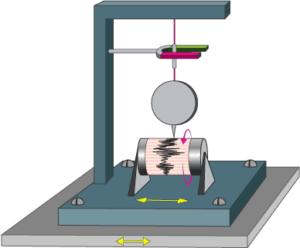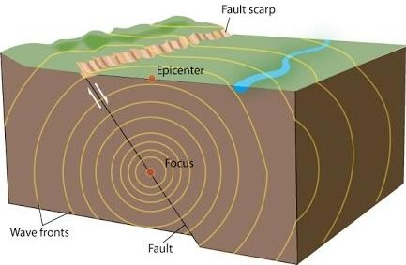During earthquake – pendulum vibrates – pen moves on paper – intensity measured this way
* Earth’s crust, part of mantle – made of large slabs of solid rocks – tectonic plates
* These plates – under land and oceans – seems to float and move – internal pressure
* Sometimes – plates stuck – instead of sliding – puts stress on the ground
* After some time – stress increases – rocks break and slide – causing earthquake – ground failure
* Boundary of tectonic plates – fault plane
* Failure at fault plane – result in violent displacement of earth’s crust – result is earthquake
* Point – under the surface – rocks break – focus
* Point – directly above the focus – on the surface – epicentre
* Magnitude – maximum at or near the epicentre
* After earthquake – tremors (vibrations) of lower magnitude – aftershocks
* May also occur – volcanic regions – tectonic faults – movement of magma
* Such earthquakes – early warning of volcanic eruptions

# Effects of Earthquake

* Shaking and ground rupture –
  + Main effects of earthquake – cause damage to buildings, other rigid structure
  + Level of damage – depend on – magnitude of earthquake, distance from epicentre, local geological features
* Landslides and avalanches –
  + Damage caused in hilly and mountainous regions
* Fires –
  + After earthquake – fires start – broken electrical or gas lines
* Tsunamis –
  + Underwater earthquake – cause tsunamis
  + Example – 2004 Indian Ocean tsunami
* Human impacts –
  + Damage to property, roads, bridges, buildings, etc
  + May damage the foundation of buildings

# Protective Measures for Earthquake

* Experts suggest – earthquakes don’t kill people – buildings do
* Most casualties (deaths) – collapse of human constructions
* Earthquakes – not predictable – BUT – loss of damage – reduced – preventive measures
* 4 basic protective measures –
  + Mitigation –
    - Efforts – reduce loss of life and property – lesser impact of disasters
    - Achieved through – risk analysis, reduction
    - Some steps –
      * Use lightweight materials – construction of buildings – reduce damage during collapse
      * Constructing buildings – solid grounds – follow building norms
      * Fixing heavy equipment, furniture to walls – do not fall during earthquake
  + Preparedness –
    - Many things – everyone must know – survival during earthquake –
      * Disaster first aid kit –
        + Food and water- at least 3 days
        + Basic medical supplies, tool kit, sanitation, family documents, etc
      * Home earthquake plan –
        + All family members – practice emergency situations
        + Safe areas in house – identified
      * Advisable – take training – emergency first aid, fire extinguishers, emergency exit plans
  + Response –
    - Keep calm during earthquake – very imp.
    - Basic safety steps –
      * When indoors – drop down to floor – take cover – under desk, table, etc – duck and drop technique – stay away from windows
      * When outside – go into open areas – away from buildings, power lines, trees, etc
      * When inside a car – stop the car – open areas – away from bridges, flyovers, etc
  + Recovery –
    - Earthquake – lot of damage – life and property
    - Effects of earthquake – long term – people – may be evacuated
    - Govt. – use disaster management plan – certain steps taken –
      * Check for injuries –
        + Do not move injured person – until very necessary
        + Provide first-aid – wherever required
      * Check for hazards –
        + Earthquakes – create other dangers
        + Very imp. – check for hazards, gas leaks, electrical wirings
      * Telephone line – functional – left free – emergency use
      * Expect aftershocks –
        + Most – smaller than main earthquake
        + Some – large enough – additional damage

# Thunderstorms

* Another natural phenomenon – thunderstorm – lots of damage
* Storms – very dangerous – lightning strikes – responsible – killing people – damage property
* Moist air – rise up – form clouds – thunderstorms are formed
* Thunder clouds – also called – cumulonimbus clouds
* Warm air moves up – moisture condenses – forming ice crystals
* Condensed moisture – comes down – gravity – air still going up
* This instability – upward, downward movement – formation of static electrical charges
* This electricity – discharged – seen as thunder and lightning

# Lightning

* Most beautiful display in nature – BUT – most deadly as well
* Lightning bolt – speed – 45 km/s (160,000 km/hr) – temperature – 28,0000 C

**The phenomenon of lightning**

* Thundercloud – move around – equal and opposite charge – induced (developed) at the ground
* Negative charges – travel downward – thundercloud to earth
* Electrical field – strong enough – electrical discharge between clouds
* During strike – air – works as conductor and expands – produce shock waves
* Shock wave – heard as thunder
* Lightning – seen before hearing thunder – speed of light greater than speed of sound
* 1752 – Benjamin Franklin – proved – electricity, lightning – same thing
* He flew his kite in thunderstorm – bottom part of string – dry
* Attached a key to the bottom part – kite – stuck by lightning
* Spark – travelled from key to his hand
* He was – lucky – didn’t die
* Next 2 persons – tried this experiment – died

# Safety Measures During Lightning Strikes

* People – stuck by lightning – receive electric shock – may be burnt
* These people – carry no charge – handled safely
* Someone – looking dead – may be revived – quick actions
* Lightning conductor – pointed metal – not attached to roof – BUT – connected to copper, aluminium piece – connected to conductive grid in the ground
* This conductor – protects building from lightning
* Purpose – lightning rods – low resistance path – to ground – conduct electrical currents – during lightning
* Lightning rod – current flows to ground – without damage
* Safety measures –
  + Never take shelter – under tall tree or only tree in the area
  + Do not stand – high ground
  + Don’t fly kite – in thunderstorm, near power line, near air field
  + Stay away – wire fences, clothesline, metal pieces, etc – metal objects
  + When in vehicle – stay inside – vehicle – act as bad conductor